Project One – Jason Goodman

Business Objective
To analyse trends in patient care by examining patient flow patterns and associated operational costs.

Proposed Plan of Action
- Evaluate the cost of each treatment and the corresponding average to identify strong revenue streams and areas requiring improvement.
- Break down income sources to understand patient payment methods and determine opportunities to optimize overall cost efficiency.
- Identify patients with high treatment volumes to gain clearer insights into patient care needs and service utilization.

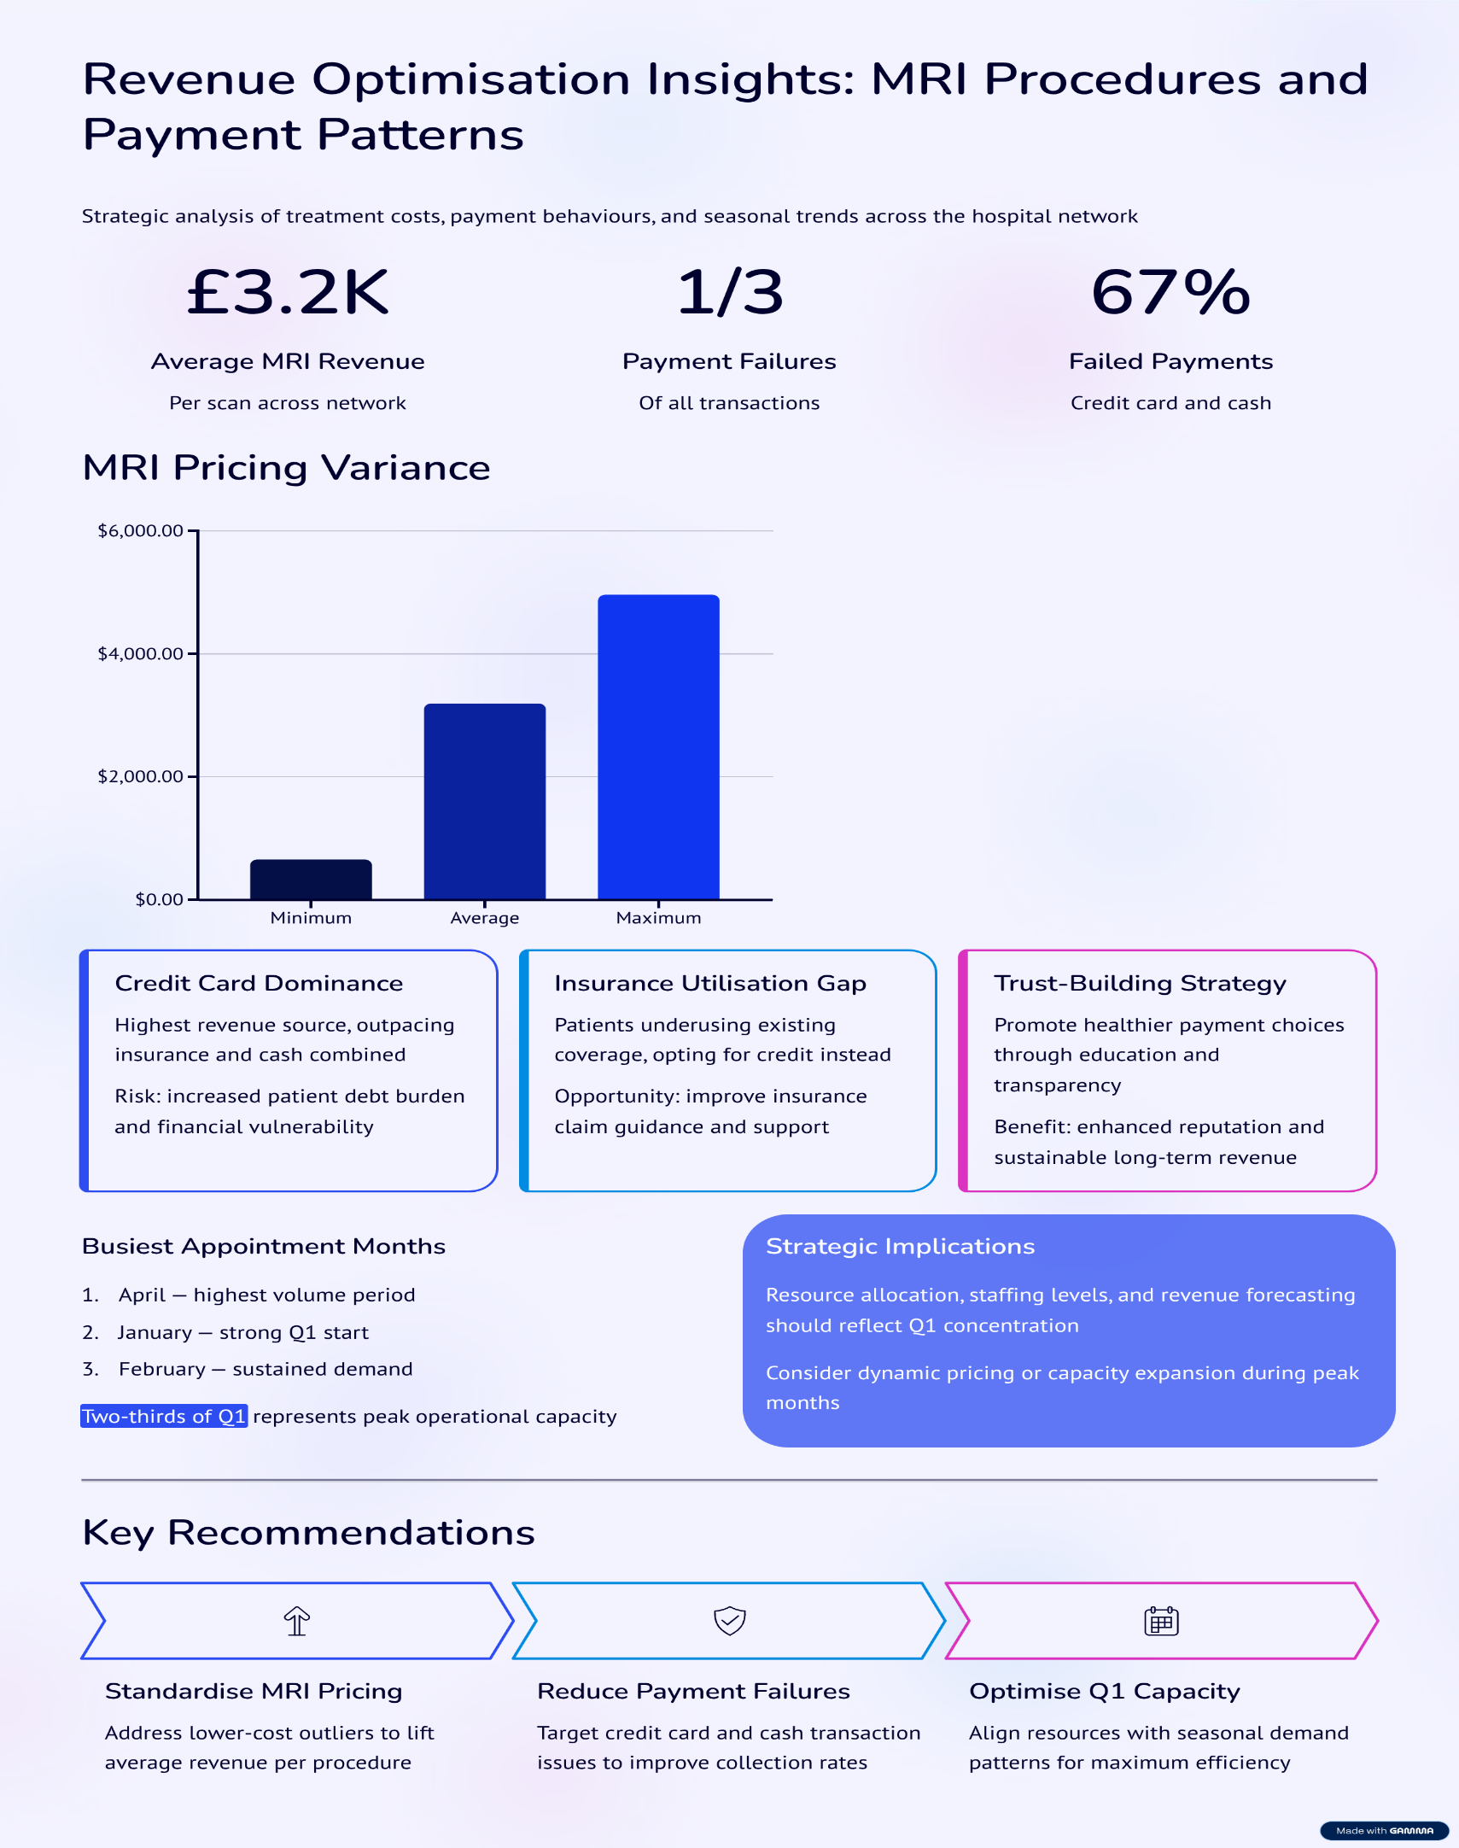

Evaluate the cost of each treatment and the corresponding average to identify strong revenue streams and areas requiring improvement.

Initial analysis of the treatment data indicates that MRI procedures represent the highest-earning revenue stream, with an average cost exceeding £3,200 per scan across the network

SQL QUERY
SELECT t.treatment_type,
ROUND (AVG(Amount),2) as Average_amount
FROM magnetic-planet-484509-d6.hospital_management.billing as b
JOIN magnetic-planet-484509-d6.hospital_management.treatments as t
ON b.treatment_id = t.treatment_id
GROUP BY treatment_type
ORDER BY average_amount;

However, when reviewing the full range of MRI scan costs from highest to lowest, a significant variance is evident, with prices spanning from £662.72 to £4,966.18. This suggests that there may be opportunities to increase revenue by addressing the lower-cost MRI cases and bringing them more in line with the higher end of the range, thereby elevating the overall average cost of MRI procedures.

SQL QUERY
SELECT t.treatment_type, b.amount
FROM magnetic-planet-484509-d6.hospital_management.treatments as t
JOIN magnetic-planet-484509-d6.hospital_management.billing as b
ON t.treatment_id = b.treatment_id
WHERE t.treatment_type ='MRI'
ORDER BY amount DESC;
Break down income sources to understand patient payment methods and determine opportunities to optimize overall cost efficiency

Key Points
- Credit cards are the dominant payment source, generating more income than both insurance and cash.
- This raises concerns about patient financial behaviour, as reliance on credit cards may increase personal debt.
- Encouraging patients to use insurance where possible or pay with cash when feasible could reduce their long-term financial burden.
- Promoting healthier payment choices can strengthen trust and improve patient relationships.
- Increased trust and transparency may enhance the organisation’s reputation, supporting long-term revenue growth.

This is further supported by the analysis of failed payments, which shows that insurance payments are the most reliable and have the lowest failure rate. In contrast, cash payments account for the highest proportion of failed transactions, indicating that many patients may be placing themselves under additional financial strain in an effort to cover treatment costs.

SQL QUERY
SELECT payment_method,ROUND (SUM(amount),2) as total_sum
FROM magnetic-planet-484509-d6.hospital_management.billing
WHERE payment_status = 'Failed'
GROUP BY payment_method
ORDER BY total_sum DESC;

Overall, more than one-third of all payments result in failure, and further analysis shows that over two-thirds of these failed transactions are associated with credit card or cash payments

SQL QUERY
SELECT payment_status,ROUND (SUM(amount),2) as total_sum
FROM magnetic-planet-484509-d6.hospital_management.billing
GROUP BY payment_status
ORDER BY total_sum DESC;

Identify patients with high treatment volumes to gain clearer insights into patient care needs and service utilization

After Checking the appointments by month, we can see that April, Jan and Feb are our highest 3 for footfall of appointments. Considering that this is two thirds of Q1 as our busiest time of the year.

Suggesting that for hospital efficiency, this would point to staffing levels need to adapt throughout the year to keep labor costs at a minimum

SQL QUERY
SELECT
FORMAT_DATE ('%b', appointment_date) as month_name, COUNT (*) as appointments
FROM magnetic-planet-484509-d6.hospital_management.appointments
GROUP BY month_name
ORDER BY appointments DESC;

Conclusion

The analysis of treatment costs, payment behaviours, and appointment patterns provides several valuable insights into both operational efficiency and potential revenue optimisation. MRI procedures remain the organisation’s strongest revenue stream, yet the wide variation in pricing indicates a clear opportunity to improve consistency and increase overall profitability by addressing lower-priced cases.

The review of payment methods highlights a reliance on credit card transactions, which not only contributes disproportionately to failed payments but may also place patients under unnecessary financial strain. Encouraging greater use of insurance and cash payments—where appropriate—could reduce patient debt, improve financial outcomes, and foster stronger trust and long-term relationships with those we serve. These changes, while indirectly related to revenue, can enhance the organisation’s reputation as a patient-centred and financially conscious healthcare provider.

Additionally, the analysis of appointment volumes demonstrates that the first quarter, particularly April, January, and February, represents the busiest period of the year. Adjusting staffing levels to reflect these seasonal patterns would allow the organisation to manage resources more effectively, improving operational efficiency while minimising unnecessary labour costs.

Overall, these insights present clear opportunities to optimise revenue, strengthen patient engagement, and improve operational performance across the organisation. If addressed strategically, they can contribute to long-term financial stability and enhanced patient satisfaction.

